Login to your ACES.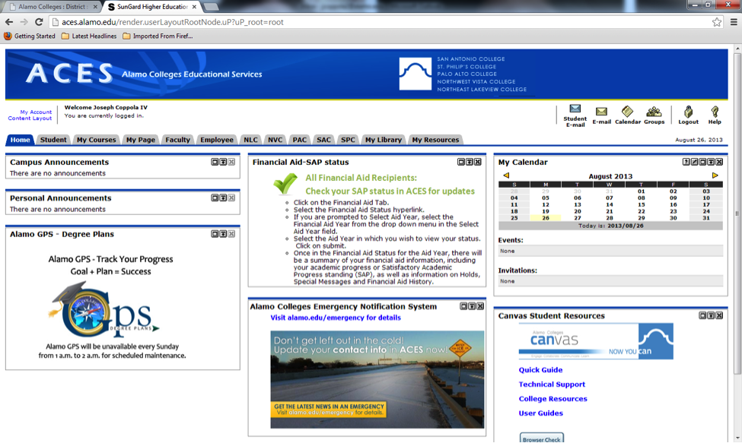
Click on the Employee Tab and click the AlamoLearn link for Click here to enter AlamoLearn
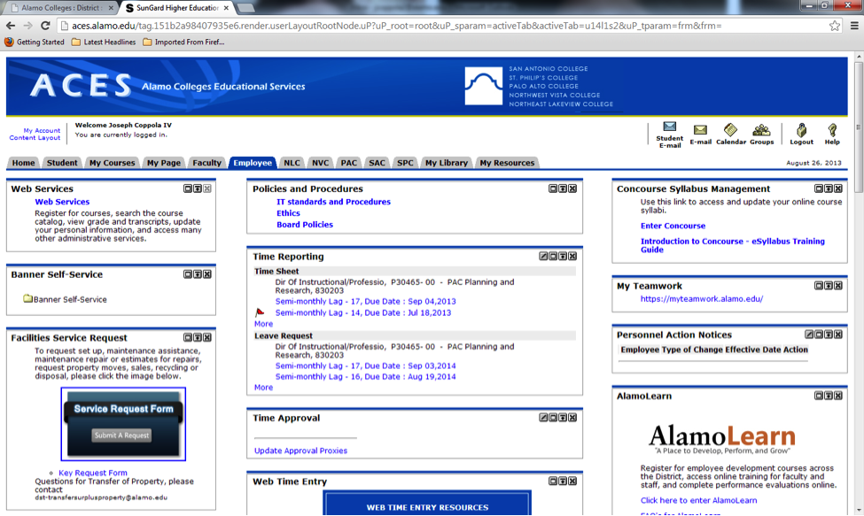

Hover your mouse over My Learning and Click View Your Transcript
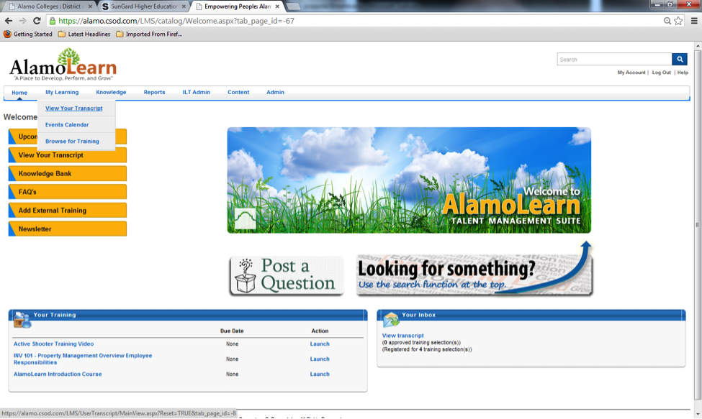
Click on the completed tab and you should see PAC Fall 2013 College Development Day. Under Options, click Evaluate to evaluate the entire sessions.
